Date: 10.10.2025
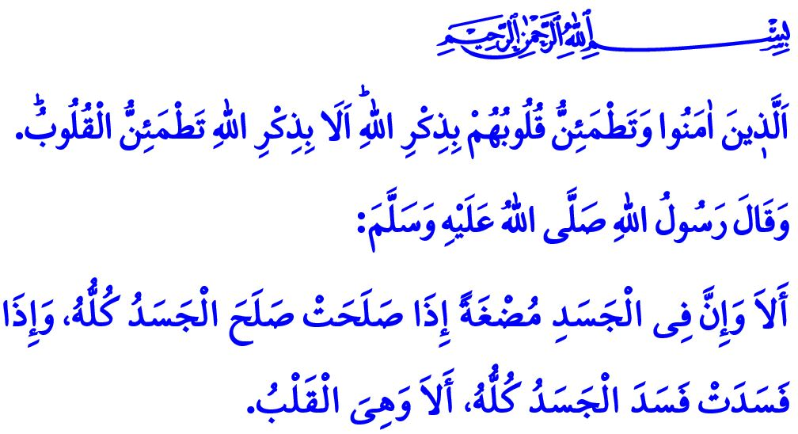THE RESTING PLACE OF ALLAH THE ALMIGHTY’S GAZE: THE HEART
Honorable Muslims!
One day, after explaining certain matters concerning what is halal and haram to his companions, our Prophet (saw) gave the following admonition: “Surely, there is a piece of flesh in the body which, if it is sound, the whole body is sound; and if it is corrupt, the whole body is corrupt. Indeed, that piece of flesh is the heart.”
Dear Believers!
The heart is the resting place of Allah the Almighty's gaze. It is the abode of faith and piety, of wisdom and understanding. It is the source of grace and refinement, the touchstone of divine love and affection. The heart is the center of love and hatred, courage and cowardice, good and evil—in short, the seat of all emotions.
Esteemed Muslims!
When people believe sincerely in Allah and His Messenger and fill their hearts with the remembrance of Allah the Almighty, they attain true peace. Indeed, as our Almighty Lord declares in the verse I have recited at the beginning of this Friday’s khutbah: ... those who believe and whose hearts find comfort in the remembrance of Allah. Surely in the remembrance of Allah do hearts find comfort.” The heart of one who recites, listens to, learns, and teaches the Qur’an, and reflects its mercy-filled message in every moment and aspect of life, becomes a vessel of divine grace. When servants free their heart from what is fleeting and bind it to what is eternal, when they polish it with the truths of Islam and purify it from sins through repentance and seeking forgiveness, they attain happiness in both this world and the Hereafter. Allah the Almighty draws our attention to this truth, stating, “... the Day when neither wealth nor children will be of any benefit. Only those who come before Allah with a pure heart ˹will be saved˺.”
Dear Believers!
If people fall prey to the deceptions of Satan and nafs; if they become enslaved by polytheism and disbelief, hypocrisy and ostentation, greed and covetousness, anger and violence—their hearts become hardened. Coldness emerges in their love, harshness in their speech, and cruelty in their behavior. If people lose their way, stray from the path of righteousness, distance themselves from acts of worship, become indifferent to what is halal and haram, and indulge in sin, their hearts become darkened. Their ear no longer heeds the truth, their tongue ceases to speak rightly, and their eye fails to perceive the truth. The warning of our Prophet (saw) on this matter is clear: “When a servant commits a sin, a black spot appears on their heart. If they abandon it and seek repentance and forgiveness, their heart brightens. But if they persist in sin, the black spot increases until it covers the entire heart.”
Dear Muslims!
Our beloved Prophet (saw) advised a companion who complained of a hardened heart to soften it by giving to those in need and by showing kindness to orphans. Indeed, with every good deed we perform, a reflection of beauty is cast upon our hearts. Showing a smiling face to our spouse and children, honoring our parents, respecting our neighbors’ rights, caring for the elderly, visiting the sick, and protecting orphans all soften the heart and bring serenity to the soul. Our duty is to strive to adorn our hearts, which are the mirror of Allah, with acts of goodness. It is to refrain from wounding or offending anyone’s heart and to keep our own heart free from heedlessness that soils it, from evils that corrode it, and from sins that darken it. It is to keep it alive through prayer, remembrance of Allah, the Qur’an, and acts of charity and virtue. Let us remember that when we illuminate our hearts with the light of Islam, we become servants pleasing to Allah.

I would like to conclude this Friday’s khutbah with the following supplication of the Messenger of Allah (saw): “O Allah, who turns hearts from state to state, make my heart steadfast upon Your religion.”

Bukhari, Iman, 39.
Ra’d, 13/28.
Shu'ara, 26/88,89.
Tirmidhi, Tafsir al-Qur’an, 83.
Ibn Hanbal, II, 387.
Tirmidhi, Da’awat, 89. General Directorate of Religious Services

